Andress High School Orchestra Handbook 2023-2024

“Music expresses that which cannot be said and on which it is impossible to be silent.” - Victor Hugo
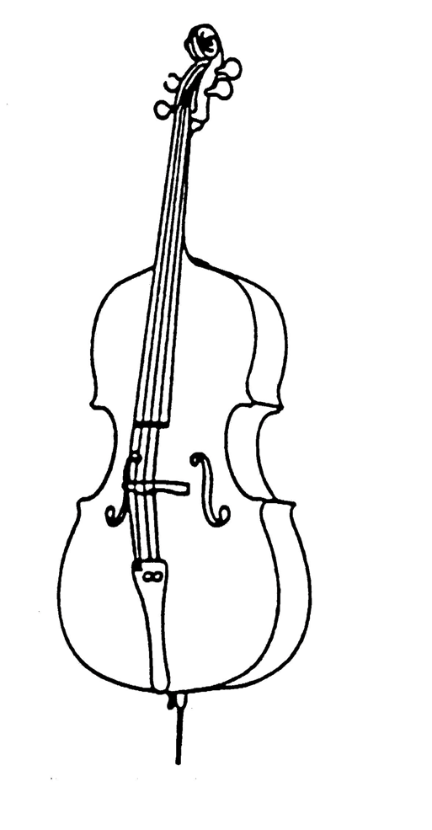

Dear Students and Parents/Guardians,
Welcome to Orchestra! Please review this handbook together - it contains important information ranging from grading policies to upcoming concerts and competitions. Students and parents/guardians will be required to sign the last page and turn it in on Wednesday (A day) or Thursday (B day). A copy is also available online at the Andress Orchestra website, andressorchestras.weebly.com.

About the Teacher
My name is Jewell Crye, and I am the Orchestra Director at Andress High School and Bobby Joe Hill Middle School. I was born and raised in El Paso and attended EPISD schools. I graduated from The University of Texas at El Paso with a bachelor’s degree in Music Education. I started playing piano at age 5 and cello at age 10. I played with the El Paso Symphony Youth Orchestra for 10 years and also participated in their Conductor's Apprentice Program. I have played as a section cellist with the Las Cruces Symphony Orchestra and for the UTEP Dinner Theatre. I also play in a string quartet and cello trio for private events. I firmly believe music is a lifelong endeavor and greatly encourage parents and family to contact me if they want to pick up any instrument - from violin to saxophone, I can help you find resources to learn on your own or with instruction.
I can be reached at jmcrye@episd.org and by phone at (915) 549-5593. Text and email is preferred!
Orchestra Goals
High school orchestra will always have a variety of players at a variety of skill levels. It is my goal to ensure each student comes out of my class with the follow musical and life skills:
1) The ability to quickly reason and make decisions.
2) The ability to form and keep good habits, such as
a) Turning in assignments on time
b) Practicing regularly
c) Expressing oneself clearly and professionally, both verbally and in writing
d) Treating others with respect, 100% of the time
e) Clearly and quickly communicating with peers and adults any issue that may affect their performance in class
3) The ability to play their chosen instruments at the level required of pieces performed by the Orchestra.
4) The ability to read music at the level required of the music being performed by the Orchestra.
5) The ability to participate as a member of a large organization with graciousness and enthusiasm.
Necessary Materials
Students will be required to have the following in class everyday:
1) 3 ring binder with front pocket
2) 20 anti-glare sheet protectors (students will be expected to procure more as needed)
3) Sharpened or mechanical pencil with eraser (must be kept in binder at all times - NO PENS)
4) Sheet music (All sheet music issued must be kept in the binder all year long, and continuing students must keep their music in their binder year to year.)
5) Rosin
6) Shoulder Rest or Rock Stop
7) Metronome and tuner (Can be an all-in-one. Phone apps are also acceptable. Tuners provided in class MAY NOT leave the room!)
8) Combination lock (NO KEYED LOCKS)
9) Instrument
10) Laptop
When instruments and bows are issued in class, students will be required to label their case (either tape or tag) with their name and class period.

Instrument Rental
Andress Orchestra has a limited number of instruments available to be issued to students.
A student may rent an instrument for the year (fall and spring semester) for $45. You can pay online here-- bit.ly/InstrumentRentalFee or pay cash in the front office. Ms. Crye will not accept any cash for rental fees. Fee waivers are available to those in need - please contact me if you are interested.
I will assign instruments when proof of payment (or signed waiver) is brought to me. Please make sure you print your online receipt.
Students are liable for damage that occurs to the instrument due to carelessness or negligence, but also have the benefit of using the EPISD Fine Arts repair shop for small issues that may crop up.
I highly encourage students rent instruments from local businesses. This is particularly encouraged for cellists and bassists, as transporting a large instrument can be a logistical issue. If a student provides proof they have a personal instrument at home, they may use a school instrument at school only, free of charge (if an instrument is available). They will not be required to take the school instrument home, but will be liable for any damage that may occur at school. EPISD Fine Arts cannot perform any repair work on instruments not owned by the district.
If you are interested in renting locally and have questions, send me an email (jmcrye@episd.org) as soon as possible and I will help you find a shop that fits your needs. As these shops serve all of El Paso, I encourage you to look into this immediately if you are interested, as the shops with the best rates tend to run out of instruments quickly.
Not taking an instrument home to practice because it difficult to transport is not an excuse for leaving the instrument at school.
Practice
All students are required to practice outside of class a minimum of 15 minutes a day. Personal practice builds skills that group rehearsal cannot. It is essential to being a successful musician.

Lockers
Students will be issued instrument lockers inside the orchestra room at the beginning of the year for during-the-day storage of their instrument. Students will provide me a copy of their locker combination, and it is imperative that if a student replaces their lock during the year, they provide me with the new combination. Keyed locks are not permitted.
Students may keep materials for other classes in their locker, but may not keep food in them. They will be required to empty and clean their locker at the end of the year.
Taking Instruments Home
Students must take their instrument home to fulfill their daily practice requirement.
Unless a student has provided proof of another instrument at home, instruments should never be left at school overnight.

Phone Policy
Students may not have their phones out in class. Phones must be kept on silent and stored in a backpack or locker. I will implement a 3 strike policy. If I catch a student with their phone during instructional time, I will verbally ask them to put it away. If it happens again, they will be given a “phone jail” bag to leave their phone in for the rest of the class period and lose points from their daily grade. On the third violation, I will require the student to leave their phone in my office during class time for one week. Additional infractions will result in parent contact.
Grading Policy
There will be a variety of grades taken in my class. They generally fall into 4 categories - participation, material checks, and afterschool rehearsals/sectionals, and concerts (test grades). I also award extra credit.
Participation
Students will start each day with a 100. Misbehavior, non-participation, and not having their instrument all result in loss of points (students who do not have their instrument receive a 0 for the day). This grade is averaged at the end of every week and added to the gradebook.
We will have after-school rehearsals and sectionals. Each rehearsal/sectional counts as a grade. I understand that there may be other events that get in the way. If you cannot make a sectional/rehearsal, navigate to andressorchestras.weebly.com. Under the “Make Up Work” tab, complete the “Sectional Make Up”. If the sectional is missed and I do not receive the make up within one week of the missed sectional, the student shall receive a zero for the grade.
Checks and Tests
We will have random pencil checks. Students must have a pencil in their binder or on their stand. If they do not have one, they will receive a 0 for the check. They will be allowed to get up and retrieve one from their locker or backpack for a 70.
We will have random binder checks. A list of items required to be in the binder will be given to the students at least 1 class period in advance. The binder will be graded based on completeness.
We will have one playing test every 9 weeks. Music played at the tempo indicated with proper intonation and rhythm will get a 100, with points off for errors. If the student knows they will be absent, they must take the test ahead of time.
Special note on chair placement - A playing test is only one of many factors that go into assigning chairs. A student may be an excellent player, but not attend rehearsals and not participate fully in class. They are less likely to get 1st chair than a person who may not play as well, but has shown more responsibility and leadership skills. Furthermore, stacking skilled players in one area while leaving weaker players by themselves leads to an unbalanced, poor sound overall. I will assign chairs based on many factors, with the overall goal of making the orchestra sound as strong as possible. A student’s individual chair placement is not a reflection of their value as a student or player. Please contact me if you have questions regarding this.
After-school rehearsals/sectionals
These activities are graded. If a student attends, they get a 100. If a student cannot attend for any reason (sports, family obligations, illness, etc.), they are to complete the alternate assignment posted on the website.
Concerts
All concerts are mandatory.
If a student misses a concert, they will be given a 0.
I will provide make up work on a case-by-case basis and require phone or in-person contact from a parent/guardian explaining the student’s absence.
Missing a concert is a very serious infraction, and I weight my gradebook in such a way that it will be very difficult to pass the class without playing the concerts.
Other miscellaneous grades will occur during the semester, such as pop playing quizzes or tuning quizzes.
All students will participate in UIL Solo and Ensemble. This event takes place on a Saturday in the spring semester, and information will be provided closer to the date of the event.

Discipline
I will follow Andress’ prescribed PBIS discipline policy. I will go over the information with students in class. A copy of my discipline plan and classroom management information can be found at andressorchestras.weebly.com under the PBIS tab. Further information on PBIS can be found here: https://andress.episd.org/parents_nest/positive_behavioral_intervention_support/ common_language_procedures
Students are expected to follow these basic rules:
1) Listen respectfully when I give instructions.
2) Follow directions promptly.
3) Keep their area organized and clean.
4) Treat everyone with kindness.

Concert Dress
When we perform, students will wear Concert Black, which consists of –
- Black dress shirt/blouse
- Black Slacks/Formal Skirt (must reach past knees when sitting down)
- Black socks
- Black dress shoes/flats. Heels are not recommended.
We have a limited number of group formalwear that may issued at the beginning of the year. Please reach out to me if you are interested in this. Students must provide their own black dress shoes.
Music outside of Andress
I highly encourage students to participate in the El Paso Symphony Youth Orchestra and to take private lessons. Information on these will be provided to the students.
All-Region orchestra is also highly encouraged – the event is fun and builds a player’s skill level exponentially. Students who participate in these will be eligible for prizes, awarded extra credit, and the opportunity to perform in Austin for the state UIL Solo and Ensemble competition if they qualify.
Participation in an outside musical activity is taken into consideration when awarding Orchestra Letters.
A Few Upcoming Performances and Competitions (all exact dates TBA due to facility availability)
- October Fall Concert @ Andress
- December Winter Concert @ Andress
- February Solo and Ensemble Competition @ Hanks

Communication is the key to success - if there is ever a question about a grade or a rehearsal or anything related to this class, please contact me. I firmly believe every situation may be resolved by quick, effective communication.
I can be reached at jmcrye@episd.org and (915) 549-5593 (call or text). Parents can also join our class Remind by texting @andresso to 81010 or inputting the class code @andresso into the Remind app or website.
Please print out the next page, fill out all information, sign and return to Ms. Crye.

TEACHER COPY (to be turned in August 9th (A day) or 10th (B Day))
By signing below, I acknowledge I have read the handbook and reviewed the requirements for Andress Orchestra.
Student Print:________________________________________
Student Sign:_______________________________________
Parent Print:________________________________________
Parent Sign:________________________________________
Student email (required):__________________________
Student phone:___________________

Primary Parent/Guardian Contact Information
Name:________________________________________________
Relationship:___________________________________________
Parent email (required):_________________________________
Parent phone (required):_________________________________
Additional Contact info: ______________________________________________________
If you have any additional things you want to tell me regarding your student you feel I should be aware of (allergies, instructional concerns such as IEP/504 plans, etc.) please feel free to tell me below!

